Rodney Beede
CS1333-201
Project #6

I tested four different types of advanced data type trees: a random order binary search tree, a sorted order binary search tree, a random order splay tree, and a sorted order splay tree. The program conducts a test using these steps:
- Fill in each tree with the specified amount of random or sorted numbers
- Pick a random number from the range of possible numbers to search for
- Grab the current time for a starting time (in milliseconds)
- Run a search on one of the trees
- When the search completes, record the current time for an end time (milliseconds)
- Repeat steps 3-5 for all the other remaining trees
- Store the results into memory
- Repeat from step 1 until the specified number of passes have been made

My test used integer numbers from 1 to 5000, made 10 passes on all of the trees, and recorded the times for each pass. I then had the program average the search time of all the passes for each tree and got these results:

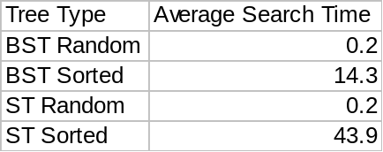

The binary search tree and splay tree both perform at very close the same speed with random data inserted about them. Sorted data on the other hand takes much longer to search through. Random data inserted into the tree requires more optimizing during addition, and therefore whenever a search is performed the likelihood of a value being found sooner is much higher. The result data shows this in how both random data trees only took 0.2 milliseconds to find some random values, while sorted data took longer.
A binary search tree adds data based on its order to other elements in the tree. It ends up splitting up data into halves on the tree and thus cutting down the possible values to be searched through. Sorted numbers, however, end up getting all their values listed to one side of the tree and thus the tree ends up resembling one long list of values. This causes the longer search time with sorted data compared to random data.
Splay trees add data by simply adding a node into the tree with the value. The tree will later on rotate values around to optimize the data more. With random data this is a fast process. Data can be added and then the tree is rebalanced based on that value. This gives an average mean in the tree of the values so a search only focuses on moving through one half of the tree.
Splay trees are slower with sorted data than binary search trees because they add values and rotate them to the root. The sorted data rotates into a chain and becomes heavily unbalanced to one side of the tree. A search ends up moving through a significant part of the tree to find a value in a mostly linear chain.
Both binary search trees and splay trees work very well when handling non-sorted data. They can optimize the data into logical halves in the trees and reduce the number of values that have to be search through. A quick comparison points to one direction and can literally cut out half of the elements being looked at. Sorted data ends up giving very little elimination of values with a comparison.

